

NW-0101 Module Datasheet

Version 1.0

1. **Description**

The NW-0101 is a highly integrated module designed by RYSE Inc.. It utilizes the Mediatek MT7688AN System on a Chip (SoC) device which is based on the MIPS 24K CPU processor core. The SoC includes 802.11b/g/n Wi-Fi, making the Omega2 ideal for Internet of Things (IoT) applications and projects. In addition to the SoC, the module includes DDR2 DRAM, Flash memory, and all of the components necessary to allow this product to be a fully functional and complete device.

* Mechanical dimensions and footprint: 20mm x 35mm, 2.8mm high
* Greater quantity of I/O signals available to the user, 42 I/O.
* No SD Card slot on the bottom.
* No Wifi chip antenna. An external antenna must be connected.

1. **Key features**

* Embedded MIPS24KEc (580 MHz) with 64 KB I-Cache and 32 KB D-Cache
* 1T1R 2.4 GHz with 150 Mbps PHY data rate
* Legacy 802.11b/g and HT 802.11n modes
* 20/40 MHz channel bandwidth
* Green AP/STA - Intelligent Clock Scaling (exclusive) - DDRII: ODT off, Self-refresh mode
* 1-port 10/100 FE PHY
* x1 USB 2.0 Host
* SPI/SD-XC/eMMC
* SPI, I2C, I2S, PWM, PCIe, UART, GPIO
* An optimized PMU
* WEP64/128, AES, WPA, WPA2, WAPI
* LEDE Linux Operating System

1. **Regulations**
   1. **List of applicable FCC rules**

CFR 47 FCC PART 15 SUBPART C/E has been investigated. It is applicable to the modular.

* 1. **Specific operational use conditions**

This module is stand-alone modular. If the end product will involve the Multiple simultaneously transmitting condition or different operational conditions for a stand-alone modular transmitter in a host, host manufacturer have to consult with module manufacturer for the installation method in end system.

* 1. **Limited module procedures**

Not applicable

* 1. **Trace antenna designs**

Not applicable

* 1. **RF exposure considerations**

To maintain compliance with FCC’s RF Exposure guidelines, this equipment should be installed and operated with minimum distance of 20cm from your body.

* 1. **Antennas**

This radio transmitter FCC ID: 2BAAG-NW0101 has been approved by FederalCommunications Commission to operate with the antenna types listed below, with the maximum permissible gain indicated. Antenna types not included in this list that have a gain greater than the maximum gain indicated for any type listed are strictly prohibited for use with this device.

|  |  |
| --- | --- |
| Antenna type | Maximum Antenna gain |
| Patch antenna | 4.4dBi |

* 1. **Label and compliance information**

The final end product must be labeled in a visible area with the following " Contains FCCID: 2BAAG-NW0101”

* 1. **Information on test modes and additional testing requirements**

Host manufacturer is strongly recommended to confirm compliance with FCC requirements for the transmitter when the module is installed in the host.

* 1. **Additional testing, Part 15 Subpart B disclaimer**

Host manufacturer is responsible for compliance of the host system with module installed with all other applicable requirements for the system such as Part 15 B.

1. **Block Diagram**

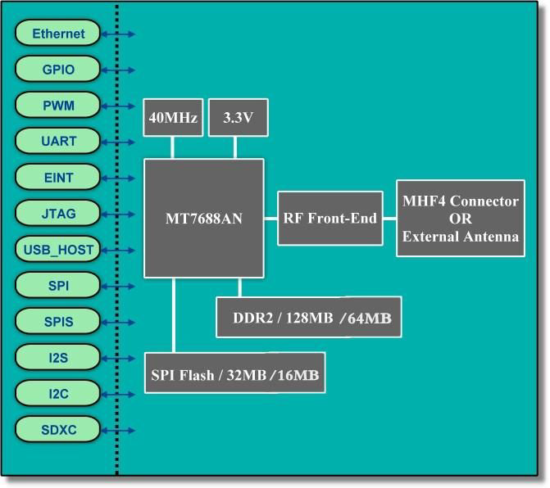

1. **Specifications**

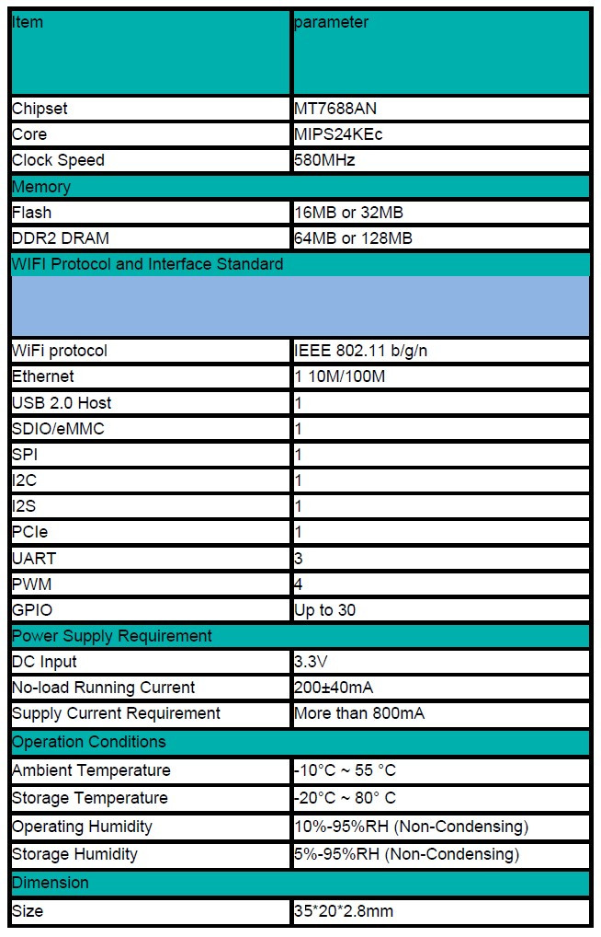

1. **Pin-Out Information** 
   1. **PinOut Diagram**

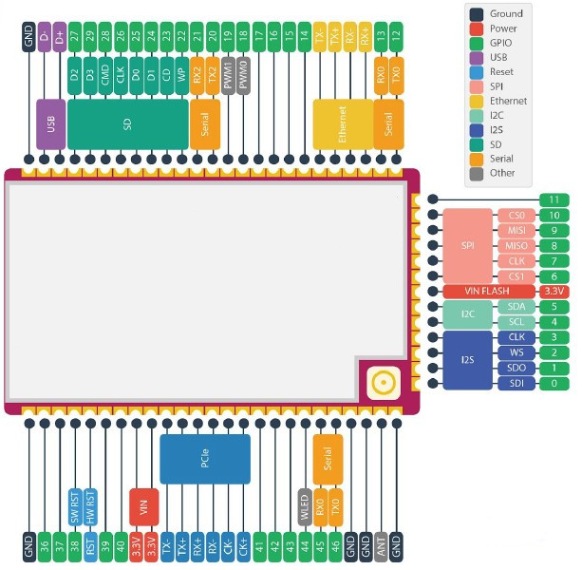

* 1. **Pin Definations**

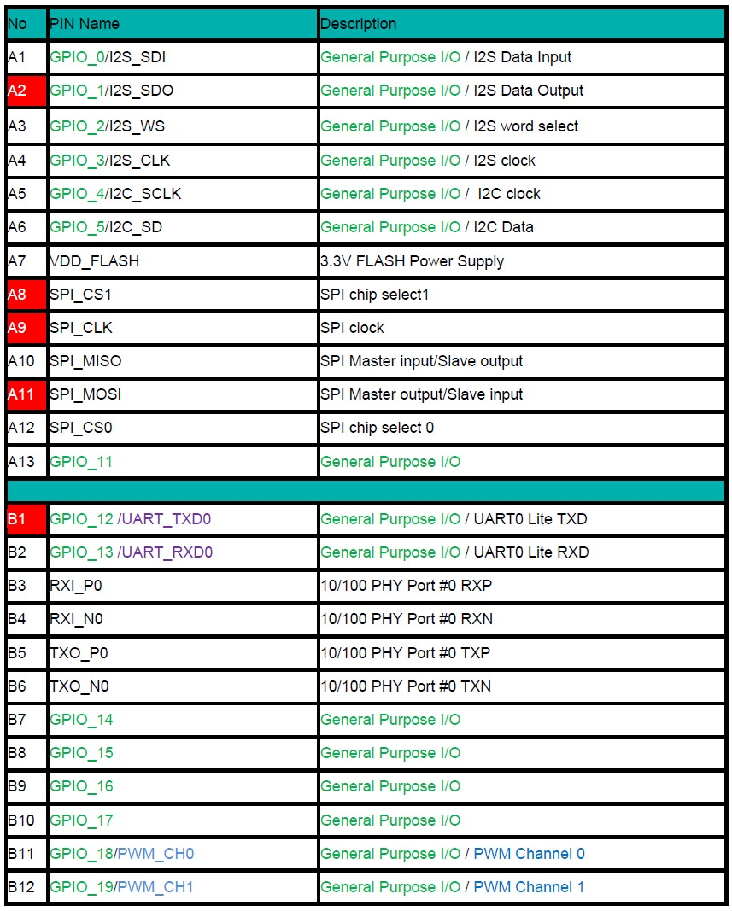

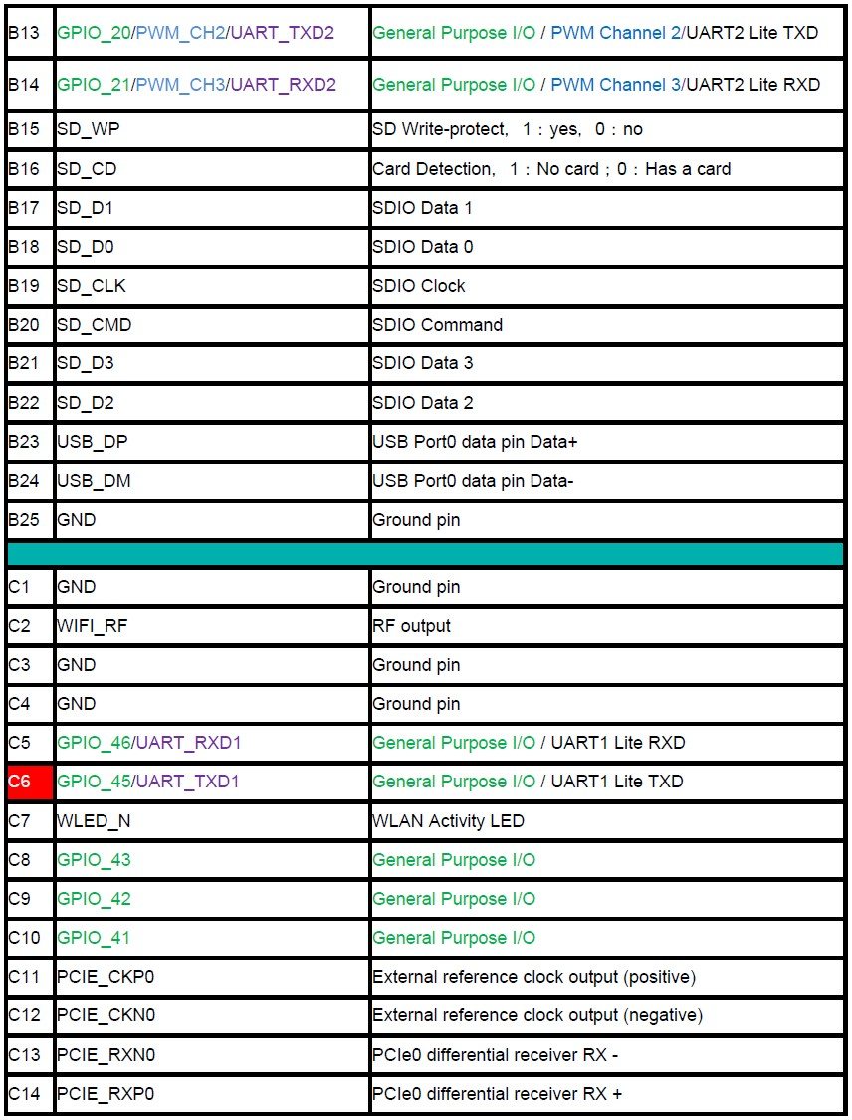

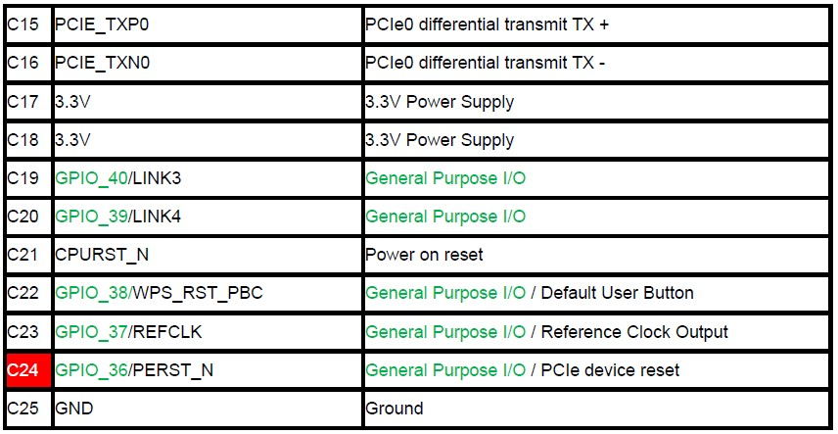

1. **Mechanical Drawing and Specifications**

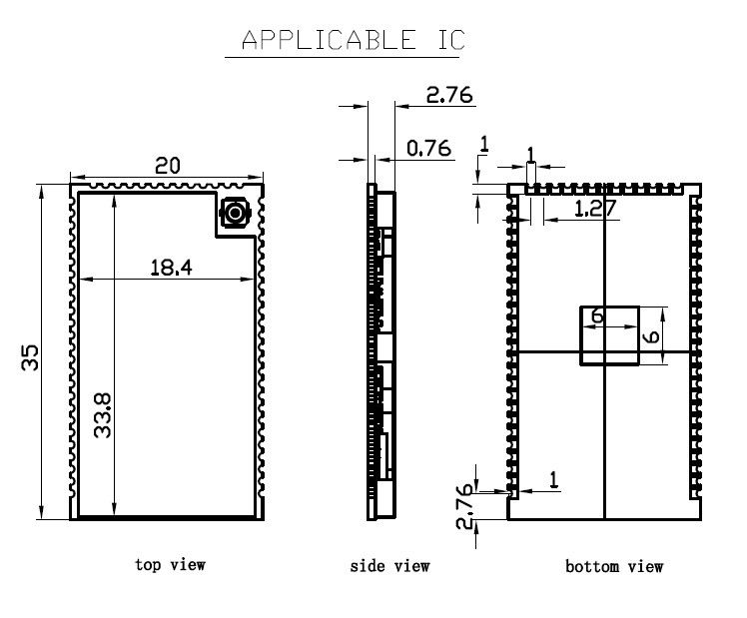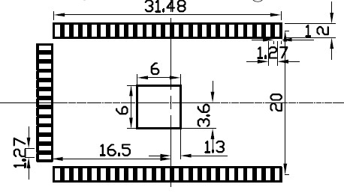

**ISED Important Note:**

In the event that these conditions cannot be met (for example certain laptop configurations or co-location with another transmitter), then the Canada authorization is no longer considered valid and the ISED cannot be used on the final product. In these circumstances, the OEM integrator will be responsible for re-evaluating the end product (including the transmitter) and obtaining a separate Canada authorization.

Any company of the host device which install this modular with limit modular approval should perform the test of radiated emission and spurious emission according to RSS-247 and RSSGen requirement, only if the test result comply with RSS-247 and RSS-Gen requirement, then the host can be sold legally.

**Note Importante:**

Dans le cas où ces conditions ne peuvent être satisfaites (par exemple pour certaines configurations d'ordinateur portable ou de certaines co-localisation avec un autre émetteur), l'autorisation du Canada n'est plus considéré comme valide et l' ISED ne peut pas être utilisé sur le produit final. Dans ces circonstances, l'intégrateur OEM sera chargé de réévaluer le produit final (y compris l'émetteur) et l'obtention d'une autorisation distincte au Canada. toute entreprise de l'hôte qui installent ce dispositif modulaire avec limite approbation devrait effectuer l'essai des modules et des rayonnements non essentiels des émissions rayonnées selon rss-247 et le cnr - gen, seulement si le résultat d'essai conforme rss-247 et le cnr - gen, puis l'hôte peut être vendu légalement.

**End Product Labeling**

The final end product must be labeled in a visible area with the following: Contains IC:30116-NW0101.

**Plaque signalétique du produit final**

Le produit final doit être étiqueté dans un endroit visible avec l'inscription suivante: Contient des IC:30116-NW0101.

**Manual Information to the End User**

The OEM integrator has to be aware not to provide information to the end user regarding how to install or remove this RF module in the user’s manual of the end product which integrates this module.

The end user manual shall include all required regulatory information/warning as show in this manual.

**Manuel d'information à l'utilisateur final**

L'intégrateur OEM doit être conscient de ne pas fournir des informations à l'utilisateur final quant à la façon d'installer ou de supprimer ce module RF dans le manuel de l'utilisateur du produit final qui intègre ce module.

Le manuel de l'utilisateur final doit inclure toutes les informations réglementaires requises et avertissements comme indiqué dans ce manuel.

This radio transmitter [30116-NW0101] has been approved by Innovation, Scienceand Economic Development Canada to operate with the antenna types listed below, It has an antenna with the maximum antenna gain is 1.78dBi

|  |  |
| --- | --- |
| Antenna type | Maximum Antenna gain |
| Patch antenna | 4.4dBi |

Antenna types not included in this list that have a gain greater than the maximum gain indicated for any type listed are strictly prohibited for use with this device.

Cet émetteur radio [30116-NW0101] a été approuvé par Innovation, Science et développement économique Canada pour fonctionner avec les types d’antenne énumérés ci-dessous.Il dispose d'une antenne avec une prise le gain maximum d'antenne est de1.78 dBi.

|  |  |
| --- | --- |
| Antenna type | Maximum Antenna gain |
| Patch antenna | 4.4dBi |

Les types d'antennes non inclus dans cette liste qui ont un gain supérieur au gain maximum indiqué pour tout type répertorié sont strictement interdits pour l'utilisation avec cet appareil.

**FCC Warning**

**This device complies with part 15 of the FCC Rules. Operation is subject to the following two conditions:**

**(1) This device may not cause harmful interference, and**

**(2) this device must accept any interference received, including interference that may cause undesired operation.**

**Any changes or modifications not expressly approved by the party responsible for compliance could void the user's authority to operate the equipment.**

This equipment has been tested and found to comply with the limits for a Class B digital device, pursuant to part 15 of the FCC Rules. These limits are designed to provide reasonable protection against harmful interference in a residential installation. This equipment generates, uses and can radiate radio frequency energy and, if not installed and used in accordance with the instructions, may cause harmful interference to radio communications. However, there is no guarantee that interference will not occur in a particular installation. If this equipment does cause harmful interference to radio or television reception, which can be determined by turning the equipment off and on, the user is encouraged to try to correct the interference by one or more of the following measures:

—Reorient or relocate the receiving antenna.

—Increase the separation between the equipment and receiver.

—Connect the equipment into an outlet on a circuit different from that to which the receiver is connected.

—Consult the dealer or an experienced radio/TV technician for help.

**FCC Radiation Exposure Statement**

This equipment complies with FCC radiation exposure limits set forth for an uncontrolled environment.

This transmitter must not be co‐located or operating in conjunction with any other antenna or transmitter.

This equipment should be installed and operated with minimum distance 20cm between the radiator&your body.

**ISEDC Warning**

This device complies with Innovation, Science and Economic Development Canada licence-exempt RSS standard (s). Operation is subject to the following two conditions:

(1) this device may not cause interference, and

(2) this device must accept any interference,including interference that may cause undesired operation of the device.

Le onjunc areil est conforme aux CNR d’ l’innovation, la science et le développement économique Canada licables aux areils radio exempts de licence. L’exploitation est autorisée aux deux conditions suivantes:

(1) l’areil ne doit pas produire de brouillage, et

(2) l’utilisateur de l’appareil doit accepter tout brouillage radioélectrique subi, onj si le brouillage est susceptible d’en compromettre le fonctionnement.

Any changes or modifications not expressly approved by the party responsible for compliance could void the user’s authority to operate the equipment.

Tous les changements ou modifications non expressément approuvée par le responsible de la conformité pourrait vider l’utilisateur est habilité à exploiter l’équipemen.

**ISEDC Radiation Exposure Statement:**

This equipment complies with ISEDC RF radiation exposure limits set forth for an uncontrolled environment.

This transmitter must not be co-located or operating in conjunction with any other antenna or transmitter.

Cet appareil est conforme aux limitesd’exposition de rayonnement RF ISEDC établiespour un environnement non contrôlé.

Cetémetteur ne doit pas être co-implanté oufonctionner en onjunction avec toute autreantenne ou transmetteur.

This equipment should be installed and operated with minimum distance 20cm between the radiator&your body.

La distance entre le radiateur et le corps doit être d'au moins 20 cm lors de l'installation et du fonctionnement de l'appareil.